**Applications of Remote Sensing with Autonomous Drones for Agricultural Use**

Shelby McCardle, Dustin Williams, Peyton Whitten, Tyler Shoemake, Durga Sai Kiran Anagani, Brycie Wiseman, Krishnakanth Yachareni, and Wanya Wartley

The University of Southern Mississippi, Hattiesburg, MS 30406, USA

CSC 414: Software Design

Dr. Partha Sengupta

December 7, 2021

**Abstract**

Drones equipped with multi-spectral imaging equipment can be used to collect data from agricultural fields which can be processed into vegetative indices. These cameras can also provide a live image feed to properly navigate the drone around obstacles. This increases the safety of operating the drone, as well as provides the pilot with a smoother operating experience. In this paper, we explore different software applications to aid with the collection and processing of agricultural data, the usability of simulated environments for researching drone-based imaging, and the application of drone-based imaging for vegetation analysis. Remote sensing is performed to capture red, green, and blue (RGB) images for vegetation analysis in the ROS-Gazebo simulated environment and reviews various vegetation indices that have been developed in recent years for spatial data and compares the usage of the interface between the geographic information system (GIS) application and remote sensing.

Using Unity and ROS/Gazebo, we were able to create a simulated drone that accurately flew and took pictures of an agricultural landscape and saved the appropriate image files necessary to create a large map of the area. Using the multiple pictures that were taken of the landscape, we then used software to create an orthomosaic that combines the separate images into a single high-resolution image, attempting to correct inconsistencies between the images like camera tilt or distortion. The software used to create aerial pictures is called WebODM, a web-based application for Open Drone Maps. Then, with aid from the geographic information system application QGIS, vegetative indices were added to our images. Microsoft AirSim, a drone simulation plugin for Unreal Engine, was used to create a simulated agricultural environment for autonomously flying and collecting image data for processing. We expanded our horizon to not only use Unity and ROS/Gazebo but also the Unreal Engine. The research provided helped to guide most of our team in having a successful experience, while also using their engine of choice. Additionally, the knowledge that the research provided helped our group in problem-solving and overall troubleshooting from other individuals who have had similar experiences. Ground control station applications, like ArduPilot and QGroundControl, and communication software, like MAVLink, were used to interface with the simulated drones in order to create, edit, and run autonomous missions with an agricultural drone that took photos of the agricultural environment through a designated flight path.

Keywords: Agriculture Drones, Simulation, Remote Sensing, Vegetation Index

1. **Introduction**

Drones are an incredible versatile machine used in everyday aspects of our lives. They can be flown by hobbyists for fun, filmmakers for powerful, aesthetically pleasing shots, and farmers for landscaping purposes, as well as keeping an eye on their crop or livestock in a safe and efficient way. Drones have proven to be capable of providing a multitude of benefits. The unmanned aerial vehicles are used in agriculture for a variety of reasons that help omit cost and unsafe conditions by using a machine in place of humans. In our study to better understand the importance of these machines, our team has conducted research and created a simulated application using different engines to make and fly a drone to take pictures of the replicated crops. We will discuss our experiences as well as the results of our simulations.

**1.1 Unity**

**1.1.1**

Unity is a real-time development platform that is used by many industries to create in 2D and 3D environments. The platform allows developers, artists, and designers to create interactive, immersive experiences while also providing tools to aid in collaboration and efficiency. Unity is used in multiple industries like game and simulation development. It is also used in automotive, transportation and and manufacturing to create interactive 3D product visualizations. Unity can be used in creating Film, Animation and Cinematics, by using its real-time rendering, and they also have a new suite that helps in every phase of the architecture, engineering, and construction lifecycle. For this project, Unity is used to create a simulation with agricultural terrain and a quadcopter drone that has cameras to take multiple images that can later be stitched into one large orthomosiac photo. This section will explain the Unity portion of the project.

For the agricultural terrain, most of the group did not have experience with Unity so tutorials were used to acquire the knowledge useful for this project. First, a flat grid was added that could be edited using brushes to create mountains or lakes. Then, there is a tool to paint the terrain with textures, whether that be with materials built into Unity, or with free assets from the Unity store. Then, paths, trees, farmland, and a lake were added to the terrain to further diversify the details. The trees that were used were from the Unity store. For simulating crops, grass prefab model from the Unity store was placed. See figure 1.1a for an example of the terrain creation processes, as well as the result. The crops were ultimately placed with the tree brush tool instead of the details brush tool, because placing them as grass was causing a glitch with the billboard effect when using the top-down camera that caused the effect that can be seen in figure 1.1b. It also changed the shading on them, which gave them less of a cartoon effect that the asset pack was initially going for.

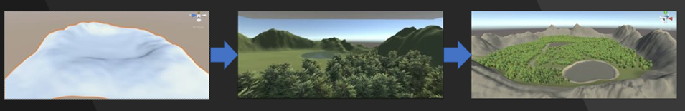

**Figure 1.1a:** Terrain Creation Process

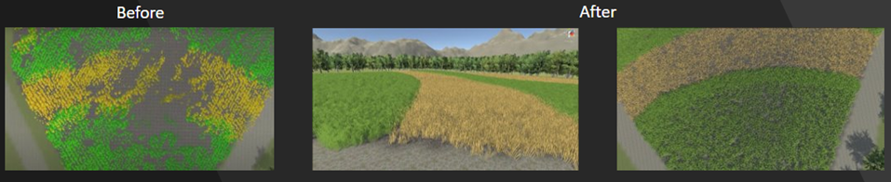

**Figure 1.1b**: Agricultural Crops Placed as Grass (Before) and as Trees (After)

For the quadcopter drone, the task was to create a quadcopter drone that had both frontal and top-down cameras, along with controllable lift, flying with translation and rotation, and landing using keyboard controls. For the drone’s model, it was initially created using a square box with 4 flat circles as a simple attempt to resemble a quadcopter. This is so scripts could be quickly tested. Subsequently, the simple model for the quadcopter was replaced with a free model from the asset store, see figure 1.1c for the before and after. Some of the scripts that were required to be created involved adding movement to the drone. Unity uses the C Sharp programming language for creating scripts, and this was the group’s first experience in script creation in Unity, so more tutorials were involved. Ultimately, four scripts were created for the drone. The first was the drone movement script which allows the user to fly up and down, rotate left and right, and lean left and right. The model new drone model from Unity’s asset store also included animations for the quadcopters rotors so the second script was created to implement the rotor animation into enable/disable script that toggles the drone movement script on and off as well, which helps with landings. The third script that was created allowed the drone’s user to use number 1 and 2 on the keyboard to switch between the frontal and top-down camera views while in the Unity simulation. The end goal was to have the top-down camera be able to capture multiple images of the agricultural terrain below, so the final script that was created allowed the user to use a keyboard control to take an image and save it to a specific folder with a specific file name, along with other parameters like the image resolution.

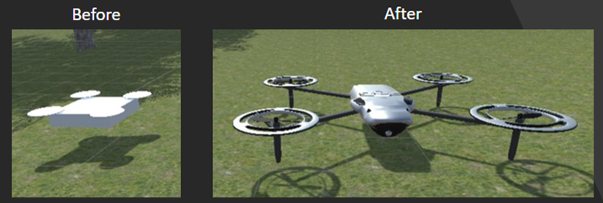

**Figure 1.1c**: Drone Model (Before & After)

Since the overall goal for the Unity simulation was to create agricultural terrain and a quadcopter drone that can capture images of the terrain while flying, the ending task of the simulation was to capture multiple images of the agricultural terrain and load the images into the WebODM application to create an orthomosaic aerial image. See figure 1.1d for an example of a single image, as well as the resulting orthomosiac photo. Sadly, a GPS waypoint implementation was not introduced since Unity’s experimental AirSim, which would allow for the creation of waypoints using QGroundControl, and could partially automate the process, is still in an experimental phase at this time, and is impossible with the current version of Unity. The implementation of a script that the user could input a grid size and it would calculate with a certain distance so the drone would automatically take pictures at specific points in that grid was also attempted, but ultimately had issues that were unresolved by the deadline. Overall, the Unity portion of this project allowed the group to discover new tools and applications for simulation development.

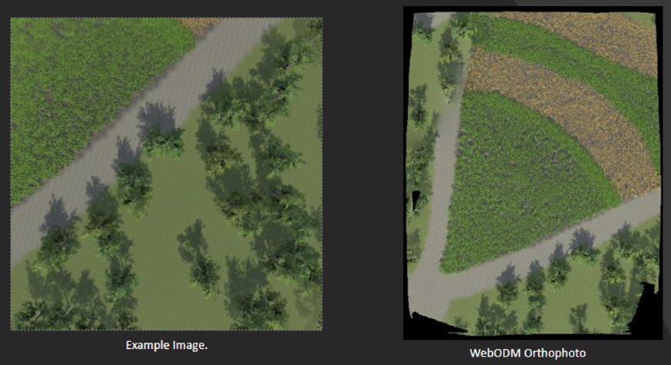

**Figure 1.1d:** Example of one of the multiples images taken (left), and resulting orthomosaic photo (right)

**1.2 Microsoft AirSim**

Microsoft AirSim is a free and open-source simulation application for autonomous and remote controlled multi-rotor, fixed wing, and ground vehicles (Shah et al., 2017). AirSim is built to be used with the Unreal game engine, however an experimental branch for the Unity engine is available to use. The primary purpose of AirSim is as a research platform for deep learning and computer vision for autonomous vehicles.

AirSim uses the built-in flight controller simple_flight by default but supports other flight controllers such as PX4 and Ardupilot. For PX4, AirSim can be configured to use hardware-in-loop mode with a hardware flight controller such as the Pixhawk 4, or software-in-the-loop mode in a virtual machine or Windows Subsystem for Linux.

AirSim includes extensive APIs to interact with vehicles and the simulation environment. The APIs are exposed through RPC, and natively support Python, C#, C++, and Java (Shah et al., 2017). The APIs expose functionality such as connecting to and controlling aerial and ground vehicles, accessing vehicle cameras, simulation manipulation such as pausing, resuming, and resetting the simulation, and manipulating the weather. Using the built-in flight controller is required to manipulate vehicles via the APIs.

AirSim also includes a data recording feature for collecting training data for deep learning (Shah et al., 2017). The record button is included in the simulated scene, and recording can also be started and stopped from the programming API.

**1.3 ROS-Gazebo**  
 Robot Operating System is a series of libraries and tools to help software engineers develop robot applications. Gazebo is a 3D simulation application that provides tools to design and accurately reproduce the dynamic simulated environments a robot may face in the real world. Gazebo with ROS is a powerful tool for robot simulation, and offers the ability to accurately simulate real robots in complex indoor and outdoor environments. However, there is a significant learning curve for beginners. This section is aimed to present the idea of how to easily understand and make use of ROS and Gazebo to simulate agriculture drones. To experiment with drone simulation, Ubuntu 16.04.6 LTS, ROS-kinetic distribution, and Gazebo 11 are used.

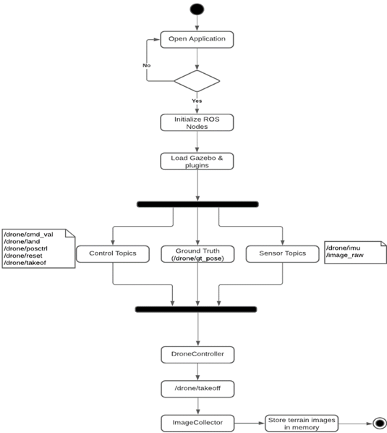

**Fig 1.3.0**

Fig 1.3.0 is an activity diagram (behavioral diagram) which is a graphical representation of drone simulation workflows of stepwise activities. When the user opens the drone software, the system initializes and loads the ROS and Gazebo modules/plugins. We have created a couple of ROS topics, for example, control topics are useful for controlling the drone, ground truth is used to get the terrain information, sensor topics are used to retrieve the sensor information from the simulation environment. When the drone takes off, it flies with a default speed and altitude. We have even been given the flexibility to control the speed and altitude of the drone with a computer keyboard. The designed drone consists of two cameras which include a front and down camera. Once the drone starts flying in the agricultural terrain, those cameras start capturing the terrain images with high overlapping. The drone captured one image every 8 seconds with a constant speed of the drone and those images are stored in the database.

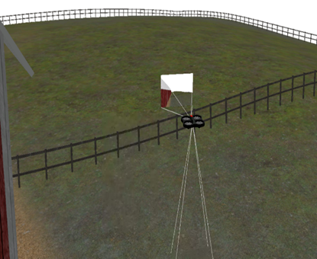

**Fig 1.3.1** (Drone flying in Agriculture terrain)

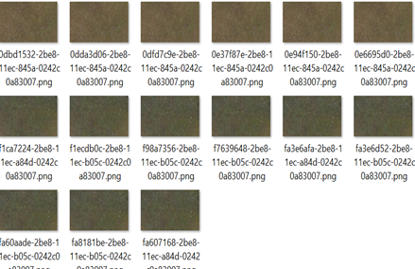

**Fig 1.3.2** (Images captured by the down camera)

The above figures are taken when a drone is flying in the agriculture terrain and took thousands of terrain pictures using its down camera. However, there are certain limitations with ROS Gazebo.

* + Gazebo does not have all the tools that a 3D Simulator like Nvidia Isaac or our ZeroSIM
  + It is difficult to import 3D models into Gazebo
  + If the developer is not a 3D modeler, it might be difficult for him to find someone who can prepare the files for Gazebo.
  + Unity provides much easier steps to import these models and has more realistic testing environments.

**1.3.1 Generating Agriculture Aerial Map Using Web ODM**

An orthomosaic is an aerial photograph geometrically corrected image which scale is uniform, corrected geometric distortion and image view has been balanced to produce a seamless mosaic dataset. WebODM (Open Drone Map) is the processing engine that takes images as input and generates different types of outputs, including point clouds, 3D models, and orthophotos. WebODM is a command-line interface and recently commercial web interface, API and other tools have been developed. We have used this software to generate an aerial map of simulated agriculture terrain.

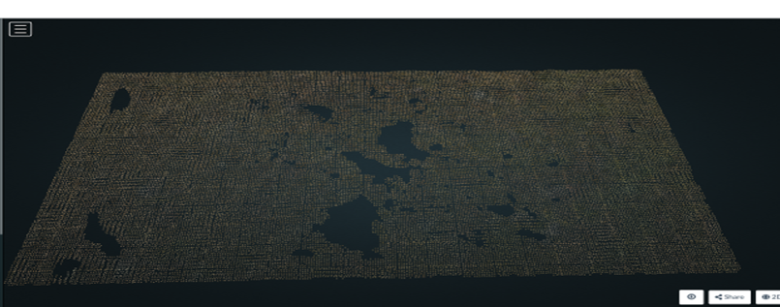

**Fig 1.3.3** (Terrain Orthomosaic 3D Map)

For our experiment, we have installed WebODM on a Linux machine. Minimum hardware requirements for ODM software are 64-bit CPU, 20 GB of disk space, and 4 GB RAM. The GPU (graphics processing unit) has no impact on overall processing performance due to there being no GPU support from ODM.

As mentioned above, the drone has captured images every 8 seconds of drone movement to keep high overlapping, and these images have been usedt as input into ODM. It processes all the images and produces the **Fig 1.3.3** 3D orthomosaic map of agriculture terrain.

**Fig 1.3.4, Fig 1.3.5, Fig 1.3.6** demonstrates the final report of the drone simulation experiment to build the aerial view of agriculture terrain.

|  |  |  |
| --- | --- | --- |
| 1. | **Reconstructed Images** | 7 over 23 shots (30.4%) |
| 2. | **Reconstructed Points (Sparse)** | 270 over 2730 points (9.9%) |
| 3. | **Reconstructed Points (Dense)** | 42,424 points |
| 4. | **Detected Features** | 650 features |
| 5. | **Reconstructed Features** | 178 features |
| 6. | **Geographic Reference** | GPS |
| 7. | **GPS errors** | 9.99 meters |

**Fig 1.3.4** (ODM Processing Summary)

|  |  |  |
| --- | --- | --- |
| 1. | **Area Covered** | 0.000009 km² |
| 2. | **Processing Time** | 50.0s |
| 3. | **Capture Start** | 01/01/1970 at 00:00:00 |
| 4. | **Capture End** | 01/01/1970 at 00:00:00 |

**Fig 1.3. Fig 1.3.5** (Dataset Summary)

**Reconstruction Details**

|  |  |  |
| --- | --- | --- |
| 1. | **Average Reprojection Error (normalized / pixels / angular)** | 0.03 / 0.19 / 0.00973 |
| 2. | **Average Track Length** | 5.01 images |
| 3. | **Average Track Length (> 2)** | 5.55 images |

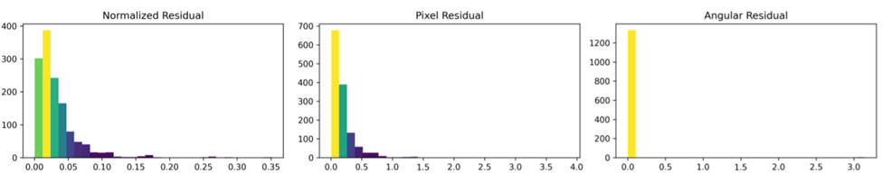

**Fig 1.3.6** (Image Reconstruction Details)

1. **Results and Discussion**

**2.1 Results**

**2.1.1 Microsoft AirSim**

*Fig. 2.1.1. Unreal Engine with Farm Environment*

Microsoft AirSim was used to create a simulated farm environment for agricultural drones. The simulation includes crops and farm buildings from free online asset packs (source) in order to create a varied environment for the drone to fly in. AirSim’s PX4 support was used to interface it with QGroundControl to fly the drone manually with a controller and fly the drone autonomously with mission planning. Due to a limitation in AirSim’s PX4 implementation, images could not be captured through PX4 and QGroundControl’s MAVLink connection. Instead, a program was created with AirSim’s Python API to fly in a grid pattern and capture an image with the downward facing camera at every grid point.

**2.2 Research**

**2.2.1 ROS and Gazebo**

Much research has been done showing the possibilities of robotic systems in real world applications such as farming, patrolling, and surveillance. Currently the standard for testing these systems in real world applications is ROS (Robot Operating Systems). ROS allows for simulation of aircraft amongst others and is standard in the scientific community. It is open-source software that allows the user to test the controls and conditions of different aircraft. Ardupilot is used specifically for drone controls. However, ROS/Gazebo only allows for one aircraft emulation at a time. With a possible extension it is a possibility of multiple vehicles that follow their own dynamics and can interreact with other vehicles. A UAV with an attitude controller that employs MAVLink for communication could make this a reality. The merger of a co-ordination algorithm in Gazebo is implemented via software modules extending ArduPilot with the ability to send/receive MAVLink messages from drones. The extraction of a communication channel where drones swap information is implemented via co-ordination script that extends locally to the drone. Every fixed time interval sends information to other drones and computes a new target point, based on the task the drones have to perform. The co-ordination of UAVs is a common problem in co-ordination systems, in order to optimize the path and time of flights by introducing a decisional architecture for the co-ordination of multiple UAVs which take into account the scenarios of surveillance with multiple UAVs.

The development environment utilizes three main elements which are Ardupilot, ROS, and Gazebo. ROS is created in such a way that programmers can develop and test robot applications while Gazebo allows for a visual simulation. Ardupilot offers different flight modes such as manual flight, automatic flight, and a combination of both. There is a mode in which the UAV flight is controlled through a guided mode where Ardupilot controls the yaw, roll, and pitch based on the position input. Ardupilot can also control the altitude using circle trajectory which forces the UAV to return to the launch point or land. MAVLink is exploited for communication with the unmanned vehicle. The exchange of packets allows for communication between vehicles, where each bit has a specific function in the communication. Packets are transmitted through serial communication channels and provided with header, payload, and checksum. MAVLink makes it possible to exchange predefined commands, some of which are used to control the communication state with the UAV or set a flight mode, it can create custom messages as well which is extremely useful.

ROS is commonly mistaken for an operating system but is in fact and open-source collection of frameworks and libraries that allows programmers to test and program robots. The software reuse in ROS is exploited which enables the interoperability in the tools in the ROS environment and problem solving. Hardware abstraction such as device drivers, libraries, and visualizers are provided for free by ROS. The components in a robot can be represented like nodes in a network that communicate with each other in ROS. This can significantly reduce the development time and create flexibility in a system. Gazebo is a necessary component in drones testing because a visual simulator is useful in testing functionality of an algorithm. Realistic and testable scenarios are easily created in Gazebo, and the environment can be filled with dynamic and kinematic physics, and a pluggable physics engine. Integration between ROS and Gazebo is provided through a set of Gazebo plugins that support several functions. A Gazebo user can easily write ROS nodes since that are compatible with simulation since the plugins utilize the same message interface in ROS and Gazebo.

**2.2.2 Drones for Agricultural Use**

Drones are incredibly helpful in agriculture since they cut costs and provide farmers with an improved way of tending to their crops that no longer involves humans. Drones are even helpful for measuring and storing information about the weather with sensors on the drone that provide farmers with a tool to measure rainfall, sunlight, and temperature (D, A.K., R, A., 2020). They could prove detrimental in some cases where human interaction could be fatal, like harmful chemicals (Mhetre, et al, 2020). Since drones could also be used in finding and identifying weeds that could harm the surrounding crops we use for food, it is beneficial to dispose of them in a timely and safe manner (Esposito, et al, 2021). By using a UAV, unmanned aerial vehicle, farmers are able to spray their crops with herbicides and pesticides to properly dispose of the weeds that could cause our food source harm (Esposito, et al, 2021). Since many pesticides and herbicides have been linked to problematic health conditions, like cancer, asthma, reproductive issues, hypersensitivity, and allergies, even with precautionary measures taken, such as suits, gloves and masks, many people still become ill or lose their life due to the harmful chemicals (Esposito, et al, 2021). Drones are also beneficial in other aspects of agriculture, such as livestock (Yaxley, et al, 2021). Sheep farms are heading sheep using drones since there are some concerns about using sheep dogs (Yaxley, et al, 2021). The concerns range from the safety of both animals, the dog getting kicked or trampled and the sheep getting bitten, to the stress of the animals (Yaxley, et al, 2021). However, these droves are not pilotless and require a person to control them to herd the animals to where they need to be (Yaxley, et al, 2021). These pilots need to be skilled and precise when operating the drone, but because of this, this method could prove to not be worth the cost (Yaxley, et al, 2021).

**2.2.3 Drone Regulations**

Drones have become increasingly utilized in the past few decades. Because drones have become much more widespread, regulation was bound to occur. As drone production ramped up and became more affordable, they have also reduced in size. This reduced size has allowed and encouraged more people to become interested. In the United States of America, the Federal Aviation Administration is the government organization responsible for maintaining safe airspace for the United States. The FAA directs air traffic around the United States, maintains space rocket launch safety for the public, conducts numerous inspections, and establishes standards for airports design, construction, and operations. Additionally, they provide standards for flight inspections, satellites, and another navigation technology.

Drone regulations continue to increase as the industry evolves. The latest rule is the operations over people rule, which was effective in early 2021. This rule expanded the freedom of flyers by allowing drone pilots who fly under a part 107 certification can operate at night and fly over cars and people. There are two main categories of drone flyers: recreational pilots and certified remote pilots. A recreational pilot is essentially a hobbyist, someone who flies their drone for fun or educational purposes. A recreational flyer must learn the rules of flying, take The Recreational UAS Safety Test (TRUST), and register their drone with the FAA if it is greater than 0.55 pounds or 250 grams. Because of the registration, there are two subcategories of recreational flyers, which are divided based on the weight of your drone. The other main category of flyer, certified remote flyers, must take and pass part 107, register drones less than 55 pounds, and it is also important to review the TRUST and recreational rules. Part 107 is an extensive comprehensive exam that tests knowledge of rules for flying drones. It covers general operations, operating rules, UAS rating, waivers, airspace classification, airspace operational requirements, airport operations, emergency procedure, aeronautical decision-making, and maintenance and inspection procedures.

TRUST is an intense exam that will prepare a pilot for all flight procedures. The exam covers all of the basic rules of flying. The rules are as follows: fly only for recreation and follow the FAA safety guidelines. Keep your drone in visual line of sight and do not interfere with manned aircraft. Fly at or below 400 feet in Class G airspace and fly at or below 400 feet in Class B, C, D, and E airspaces with authorization from LAANC or DroneZone. Take the TRUST test and carry it when you fly and have drone registration if your drone is above 250 grams. Do not operate under the influence and do not interfere with law enforcement or emergency response. Additionally, there are some other laws that are somewhat ambiguous. The peeping tom law is something that applies to drones, do not use drones for malicious activity and only fly in public airspace, or in private airspace with permission. You also cannot attach weapons to your drone.

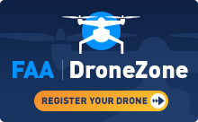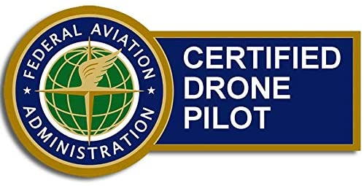

Drones have evolved from being fun hobbies to learning more about land and crops. It does not stop there, as drones have recently been created that will destroy vehicles. These drones are essentially bombs that explode on impact and have recently been being used for the United States Army. This completely changes the state of warfare. This technical feat gives advantages over any enemies, but additionally since the United States has the technology to produce remote pilot bombs, other countries undoubtedly have some similar technologies. If they have not already produced this tech, it is not long before it happens. There are plenty of other risks, such as what if the drones get into the wrong hands, mass destruction is sure to occur.

**2.2.4 Sentinel-2: Satellite for Crop Specific Monitoring**

The use of satellites to monitor the crop and support the precision farming has attention these days. The European Space Agency (ESA) has launched the satellites called Sentinel-2 A, B on 23 June 2015. These two identical satellites rotate in the same orbit across the earth and captures the high spatial resolution images. Those images are sent to earth and stored in database servers where specific teams can monitor the images. The main application or features of these satellites include agriculture, land ecosystems monitoring, forest management, inland and coastal water quality monitoring, disasters mapping and civil security. The image below shows a general overview of the Copernicus Sentinel-2.

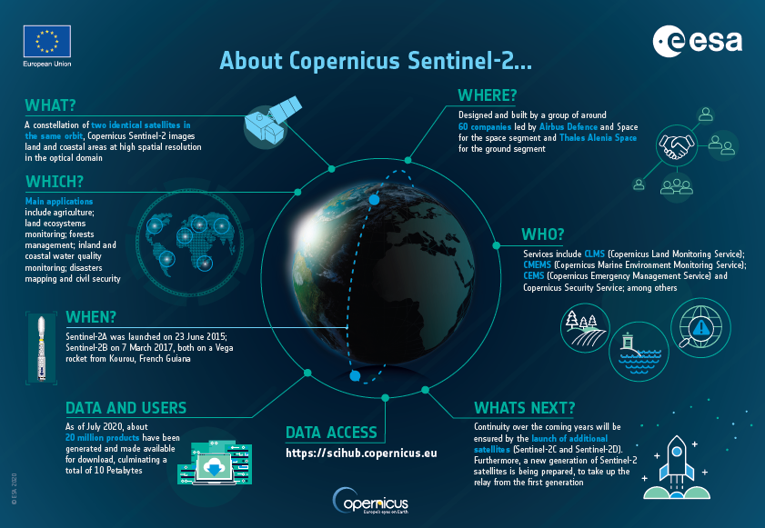

The sensors that are present in the satellite can help monitor crops and agriculture fields. The plants absorb sunlight, and the electromagnetic radiation reflected by them provides information about their biophysical composition and physiological status, which may be monitored by satellite sensors. These satellite images can assist with precision agriculture. Precision agriculture is a management strategy that uses spatial information to support management decisions based on projected images and can improve the efficiency of agricultural production.

**2.2.5: Vegetation Indices with Multispectral Drones**

The Vegetative Index has been in use since 1974. These are a combination of spectral bands. They help identify the health of the plant, radiation absorption, the amount of chlorophyll a plant has, and green biomass. There are many multispectral sensors, these sensors include examples like Normalized Difference Vegetation Index (NDVI) and Enhanced Normalized Difference Vegetation Index (ENDVI) captured via multispectral camera remote sensing drones. The NDVI is one of the commonly used vegetative indices. The NDVI is computed by dividing the difference and the sum of the NIR and RED. NDVI is a graphical indicator and is typically used to analyze RS measurements. NDVI can also be used to show the growth of vegetation.

In contrast to the NDVI, the ENDVI uses blue and green visible light instead of red visible light. The ENDVI is superior in terms of monitoring plant health. It is more reliable in terms of keeping track of the health of the plants/crops. The ENDVI is especially important to people in the farming industry. They are capable of uploading multispectral images of their crop field into precision analytics. The feedback from these images would allow the farmer to see drought, flood, and if the crop were not fertilized enough or over fertilized. The calculation for the ENDVI is different. The formula for ENDVI is (NIR + Green)-(2*blue) / (NIR + Green) +(2*blue).

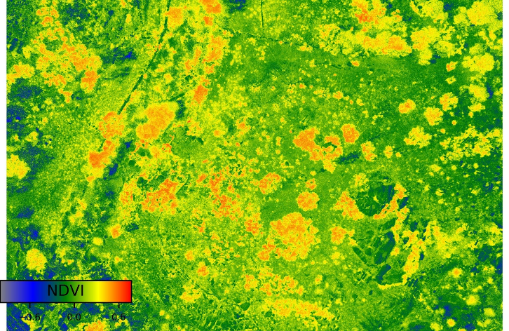*Figure 2.2.5a NDVI bands*

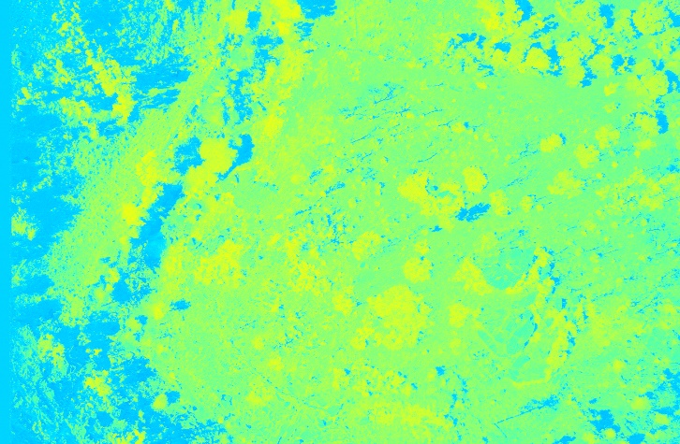*Figure 2.2.5b ENVI bands*

The above figures show the difference between the NDVI and the ENDVI. The NDVI shows more details than the ENDVI. The figures also show the difference between the red colors of the NDVI and the blue and green colors of the ENDVI. This allows the ENDVI to see more of the plant health and isolation.

1. **Conclusion**

Unmanned aerial vehicles in agriculture provide us with an unmatched tool that makes life easier for the farmers that use these vital machines. From livestock to crops, these drones assist farmers in establishing a safe and efficient environment so that they can improve their quality of life. Drones can be used in other professions to better aid others as well as just be used by a hobbyist if everyone abides by the rules and regulations of their state regarding drone usage. There is no doubt, from our research and experience with the simulation, that our understanding of these incredible advancements in technology has greatly improved.

1. **Acknowledgement**

We would like to thank the University of Southern Mississippi for allowing independent studies in this class. We would also like to express our deepest and sincerest gratitude to our professor, Dr. Partha Sengupta, for giving us an environment to gain insight about an important topic as well as providing us the skills and opportunities to share and express the knowledge we have gathered from this project.

1. **References**

D, A. K., & R, A. (2020). DRONE INTEGRATED WEATHER SENSORS FOR AGRICULTURE PURPOSE. Retrieved 2021, from https://d1wqtxts1xzle7.cloudfront.net/65395808/IJEET_11_05_009-with-cover-page-[v2.pdf?Expires=1638305768&Signature=XdD1UGXegM3gUKSWT9HiqaQv0jp5BPrqCEIjUfupk2pvR7La2XzxZwpiFcs6H4g7EA7tVkBkll0j0AK50Q28XMQW5zb-Fd53zUcIrO5QUn9lg7uFGbat8DtABarOuKa4nZePUSmye-b2NiQd-nbGd-NDhaLAkJ6ArbJ5YoxnHzuiSlP0EsaMGg9ndK5Kr0ncZc7ggFKvmaGE7hwzLv4AhV4124WVhATTV5goan6VKedXUVgrloFL9PR302yUDL4aaUdqXnjVy~7lKF1n1UZ3PX-wM2Glghtty~LkpS0cbcKnFxnNblJmqYZJrkFbsFpm-tFtjq03Qlm7hFaD-L8RXg__&Key-Pair-Id=APKAJLOHF5GGSLRBV4ZA](https://d1wqtxts1xzle7.cloudfront.net/65395808/IJEET_11_05_009-with-cover-page-v2.pdf?Expires=1638305768&Signature=XdD1UGXegM3gUKSWT9HiqaQv0jp5BPrqCEIjUfupk2pvR7La2XzxZwpiFcs6H4g7EA7tVkBkll0j0AK50Q28XMQW5zb-Fd53zUcIrO5QUn9lg7uFGbat8DtABarOuKa4nZePUSmye-b2NiQd-nbGd-NDhaLAkJ6ArbJ5YoxnHzuiSlP0EsaMGg9ndK5Kr0ncZc7ggFKvmaGE7hwzLv4AhV4124WVhATTV5goan6VKedXUVgrloFL9PR302yUDL4aaUdqXnjVy~7lKF1n1UZ3PX-wM2Glghtty~LkpS0cbcKnFxnNblJmqYZJrkFbsFpm-tFtjq03Qlm7hFaD-L8RXg__&Key-Pair-Id=APKAJLOHF5GGSLRBV4ZA).

Esposito, M., Crimaldi, M., Cirillo, V., Sarghini, F., & Maggio, A. (2021, March 25). Drone and Sensor Technology for Sustainable Weed Management: A Review. Chemical and Biological Technologies in Agriculture. Retrieved November 30, 2021, from <https://chembioagro.springeropen.com/articles/10.1186/s40538-021-00217-8>.

Mhetre, P. S., Soni, D., Nerkar, A., & Vishal, H. (2020). Agriculture drone for fertilizer spraying - irjmets.com. Retrieved November 30, 2021, from <https://www.irjmets.com/uploadedfiles/paper/volume2/issue_6_june_2020/1665/1628083049.pdf>.

Shah, S., Kapoor, A., Dey, D., & Lovett, C. (2017). *AirSim: High-Fidelity Visual and Physical Simulation for Autonomous Vehicles*. Field and Service Robotics, 621–635.

NBCUniversal News Group. (2021, December 7). *Kamikaze drones: A new weapon brings*  *power and peril to the U.S. military*. NBCNews.com. Retrieved December 7, 2021, from [https://www.nbcnews.com/news/military/kamikaze-drones-new-weapon-brings-power-](https://www.nbcnews.com/news/military/kamikaze-drones-new-weapon-brings-power-peril-u-s-military-n1285415) peril-u-s-military-n1285415.

*Secondary navigation*. Unmanned Aircraft Systems (UAS). (2021, September 20). Retrieved December 7, 2021, from <https://www.faa.gov/uas/>.

Yaxley, K. J., Joiner, K. F., & Abbass, H. (2021, April 8). Drone approach parameters leading to lower stress sheep flocking and movement: Sky Shepherding. Nature News. Retrieved November 30, 2021, from <https://www.nature.com/articles/s41598-021-87453-y>.

Bernardeschi, C., Fagiolini, A., Palmieri, M., Scrima, G., & Sofia, F. (2019). Ros/Gazebo based simulation of co-operative uavs. *Modelling and Simulation for Autonomous Systems*, 321–334. <https://doi.org/10.1007/978-3-030-14984-0_24>